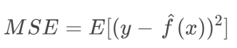

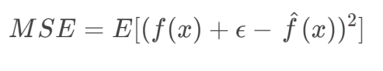

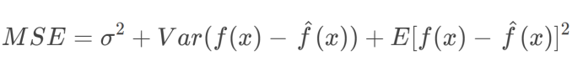

MSE (Prediction error) = Variance + Bias2 + Variance of Irreducible noise

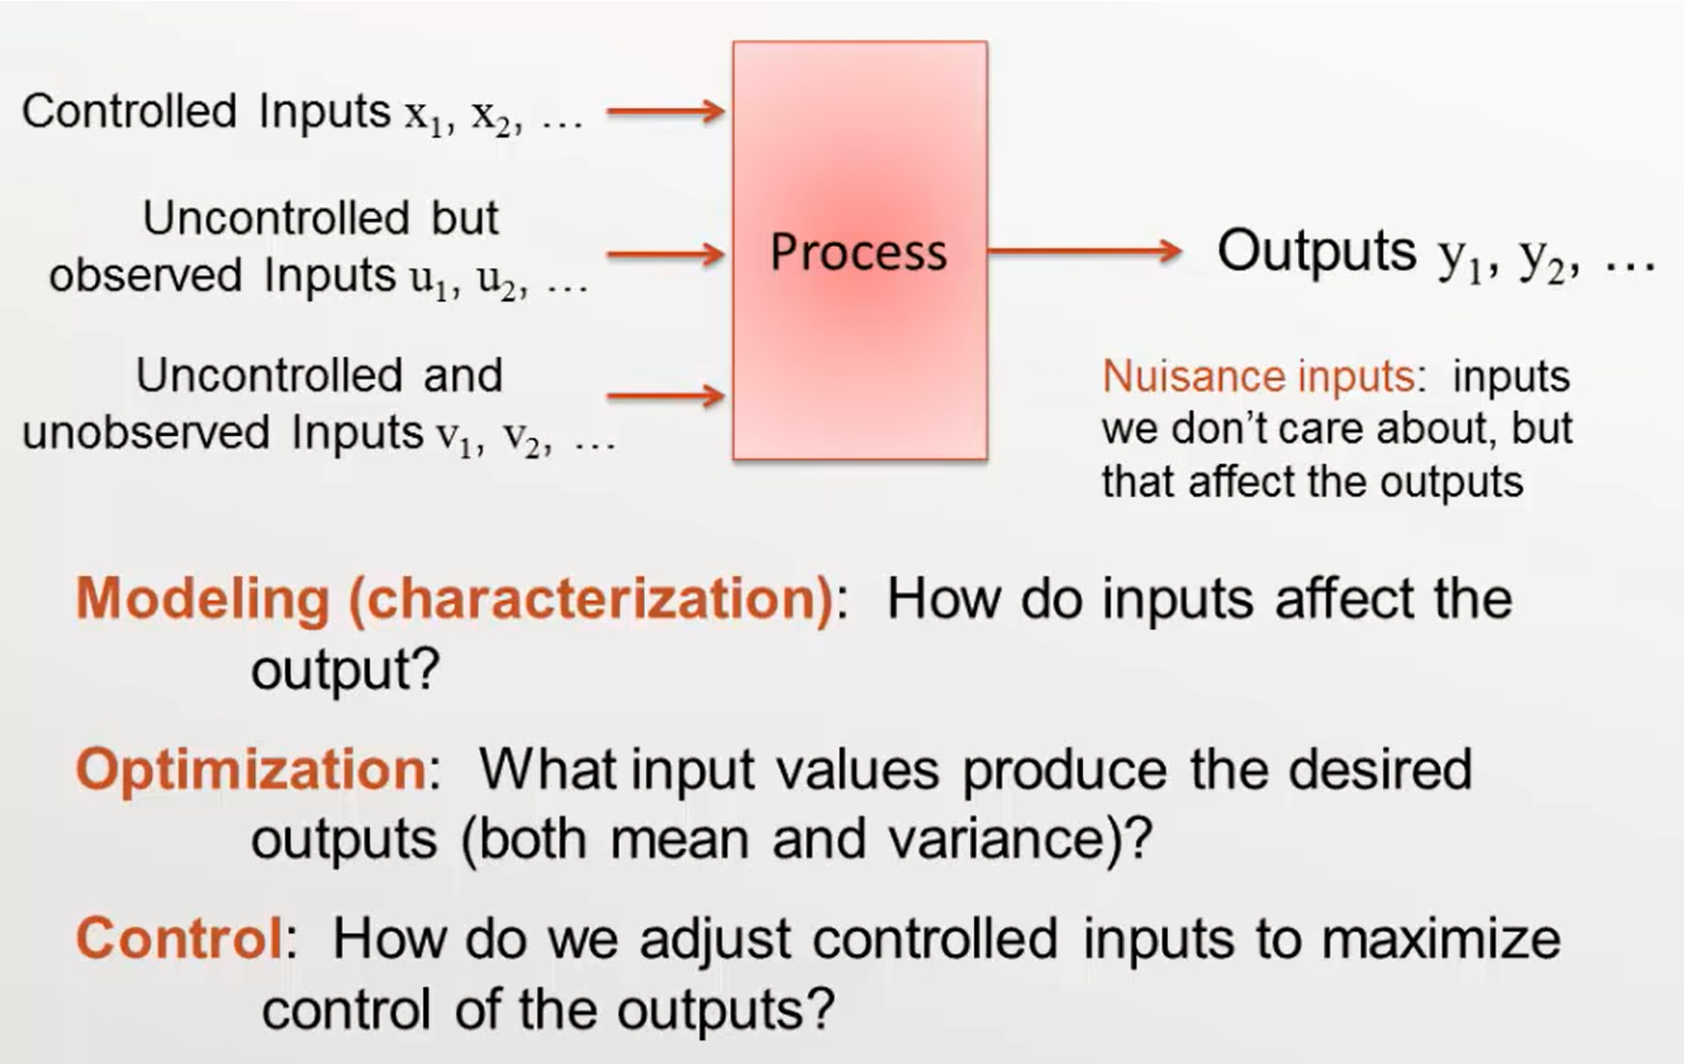

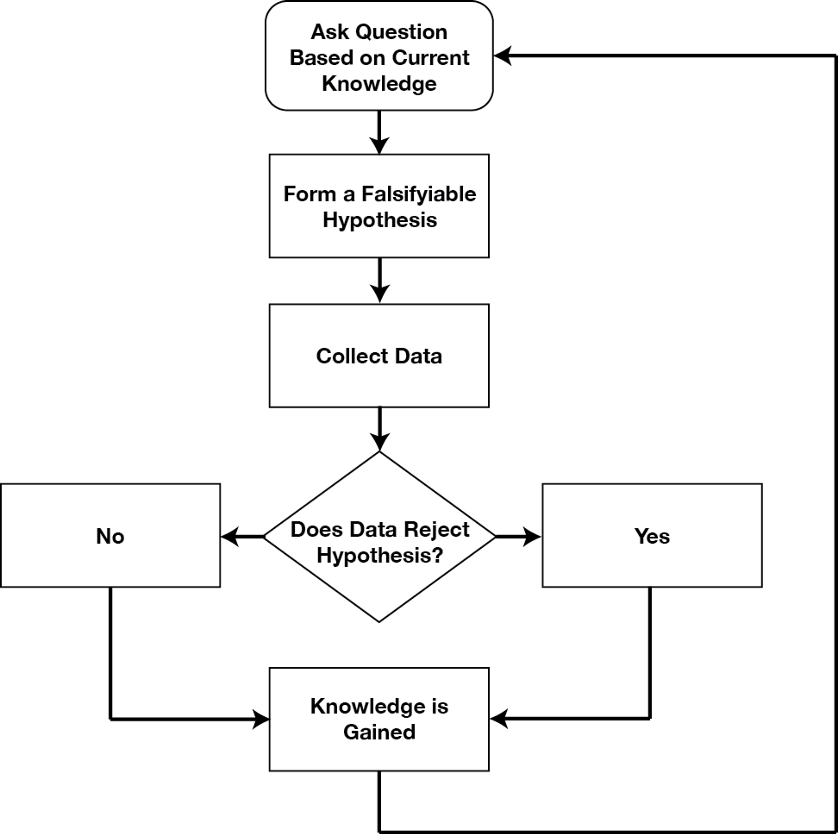

What is data?

* Data is what has been **measured/recorded.**
* What is the **definition** of the thing being measured?
* Measurement is always **with estimate of uncertainty.**
* Experimental/measurement context
  + Measurement method
  + Sample
  + Instrument
  + Surrounding Environment
* Context uncertainty(uncertainty of control and uncontrol input parameters)
* **Measurement model**
  + Indirect measurement
  + Assumption of measurement works
  + Theory and definition of things being measured

* 

 